**EXPERIMENT : 11**

**FOREIGN TRADING SYSTEM**

USE CASE DIAGRAM

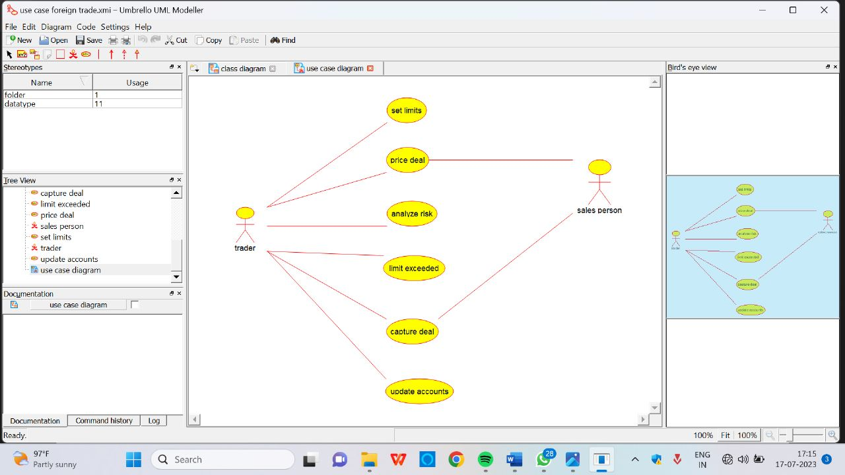

SEQUENCE DIAGRAM

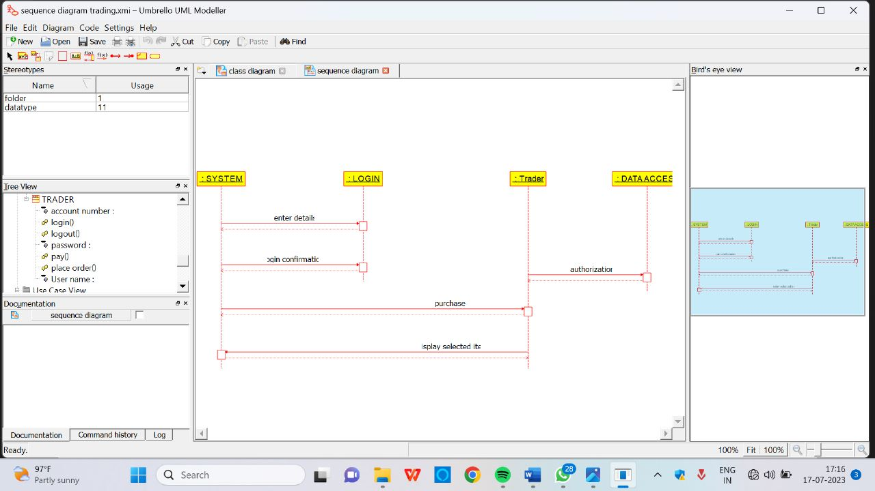

CLASS DIAGRAM

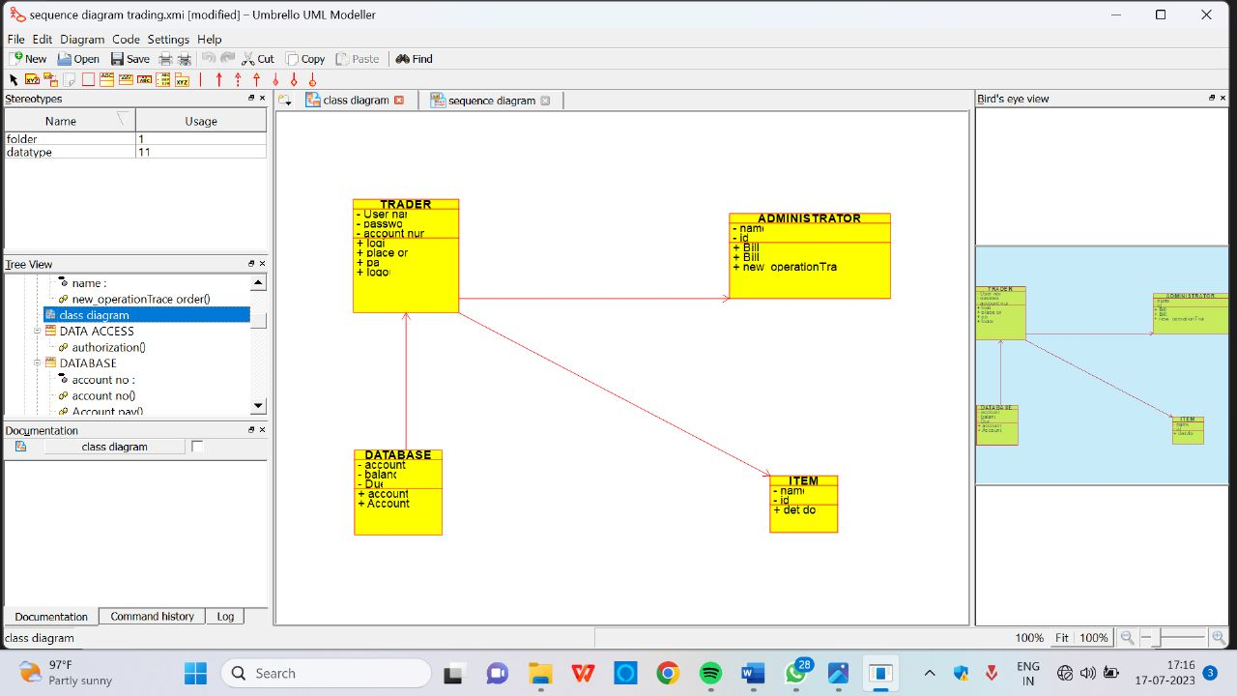

ACTIVITY DIAGRAM

